

JAD2 Meeting Notes

Members:

Justin Goulet, Chris Larsen, Mikal Callahan, Brock Corbett

# Document Objective

To reinstate meeting topics and obtain understanding of what is expected prior to the next meeting.

# Meeting Notes:

## Sorted by Member & Topic

### Justin Goulet:

#### Outstanding Items Review

Reviewed what we covered last meeting

* Present research document to customer
* Summary of Phase 1 tasks
* Object requirements / definitions

#### Goals

Outlined what must be completed before our next meeting

* Decision matrix - with options and selection criteria defined
  + How we interpret requirements
  + Ability to theme out prototype
  + Does not need to be actual prototype but a decision of how we are going to proceed
* Skeleton of information that needs to be passed in
* D3 (d4?) & others: cost/features
* Does it meet requirements
* Begin user manual, but it will not be finalized
* Live matrix what we are working towards so we can go back and reiterate if necessary

Prototype 1: 3/22

* Updates to current docs
* Working prototype of simple theme
* Complete code base for implementing prototype
* Initial documentation for using prototype

Prototype 2: 4/5

* updates to current docs
* two or more working prototypes

Prototype 3: Final

* Multiple themes on multiple prototypes
* Copies of all final versions

### Chris Larsen

#### Object Definition

Only 2 fields are required:

* Id
* Name

Important field, but may not be filled:

* States

Other object information:

* Specific themes for what will be viewed or displayed (just name, description/more details/colored states/etc.)
* Expect object coming in well-defined and we are theming/visualizing it
* When creating a new workflow/state - increment id by 1 is okay but without id (or temp) would be most appealing

### Mikal Callahan

#### Design

Rough layout:

* Have clock and hours (2/4 hours), cost, schedule, iteration through (rev) around each state
* Quality always defines background color of the box
* Time (2/4), cost ($$), iteration - cycle number(rev)
* Ranking system (1,3,5) so quickest pop up faster

Part workflow (Slack 2/21)

* New workflow (from slack 2/21) can exist without existing workflow in place
* 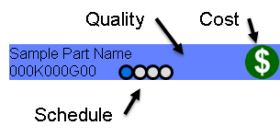
* 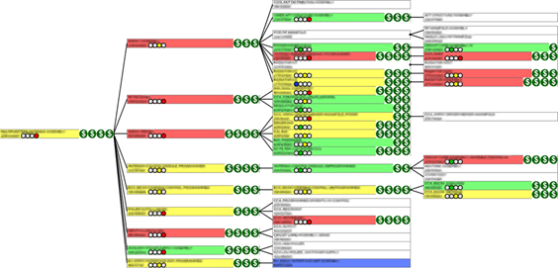
* 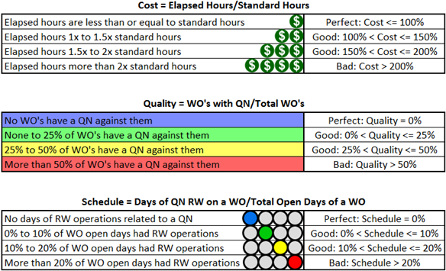

### Brock Corbett

#### Project Technologies

Find >= 5 libraries to look at

* Why did we choose it?
* Order by which seem most doable
* Decision tree

Our decision tree will help explain why we chose what we did considering cost, functionality, and integration features.

#### Feasibility

IEEE SRS requirements

* Both:
  + Workflow tree theme (simple)
  + Product Structure Tree theme (components list of each state)
* Can the client manipulate object slightly (new attributes for different theme - specific to theme e.g. Cost, time, schedule)?
  + What is the process to add more objects or aspects of states?
* Customization is high priority
* Create state - draw arrows
* State should be black box (once one is done the other should just work)
* We are going to map requirements